Fridge Chef - Build Notes
Oct 7, 2026 · @Noel Gomes

Summary
Fridge Chef is a live web tool that reads photos of a fridge or pantry, lets the cook correct the list, then suggests one stovetop dish. It runs at https://fridge-chef.technoelogy.workers.dev.
Built 3 to 7 Oct 2026. The first version went live on 5 Oct and the two-step flow (read, correct, cook) on 7 Oct. Hosting costs ₹0. The only spend is a prepaid Anthropic credit of $5.00 with a $5 monthly limit.
Tested on a phone: the full flow works end to end. Photo-reading accuracy is still being scored, with 2 of 10 planned test photos done.

Tech stack
Eleven rows; only the two Anthropic API models carry a variable cost.
Layer | Tool | Why it was chosen | Cost
Reading photos | Anthropic API, claude-sonnet-5-5 | Vision accuracy matters most at this step, and cluttered fridges are hard to read | Price not verified
Writing the dish | Anthropic API, claude-haiku-4-5-20251001 | The recipe step is text only, so the cheapest model is enough | Listed at $1 input and $5 output per million tokens
Server proxy | Cloudflare Workers, free plan | Keeps the API key out of the browser; free plan allows 100,000 requests a day | ₹0
Page hosting | Workers static assets, same Worker | One deploy and one URL, so no cross-site setup | ₹0
Rate limits | Cloudflare KV | Per-IP and global daily counters; free tier allows 1,000 writes a day | ₹0
Front end | One HTML file, plain JavaScript and CSS | No build step; readable on a phone; light and dark themes | ₹0
Prototype | Claude artifact | Tested the idea in minutes with no infrastructure | ₹0 on an existing Claude plan
Deploy tooling | VS Code, Node v24.6.0, Wrangler 4.147.0 | One command deploys; wrangler tail shows live logs | ₹0
Account security | Cloudflare login with authenticator-app two-factor | The account holds the API key as a secret | ₹0
Local testing | Node mock tests, jsdom page simulation | Caught bugs in the worker and page logic before deploy | ₹0
Domain | technoelogy.com, plus the workers.dev name technoelogy | Test link now; chef.technoelogy.com later | Domain already owned

How one request flows
Each dish takes two trips through one Worker: first to read the photos, then to cook from the list the cook confirmed.
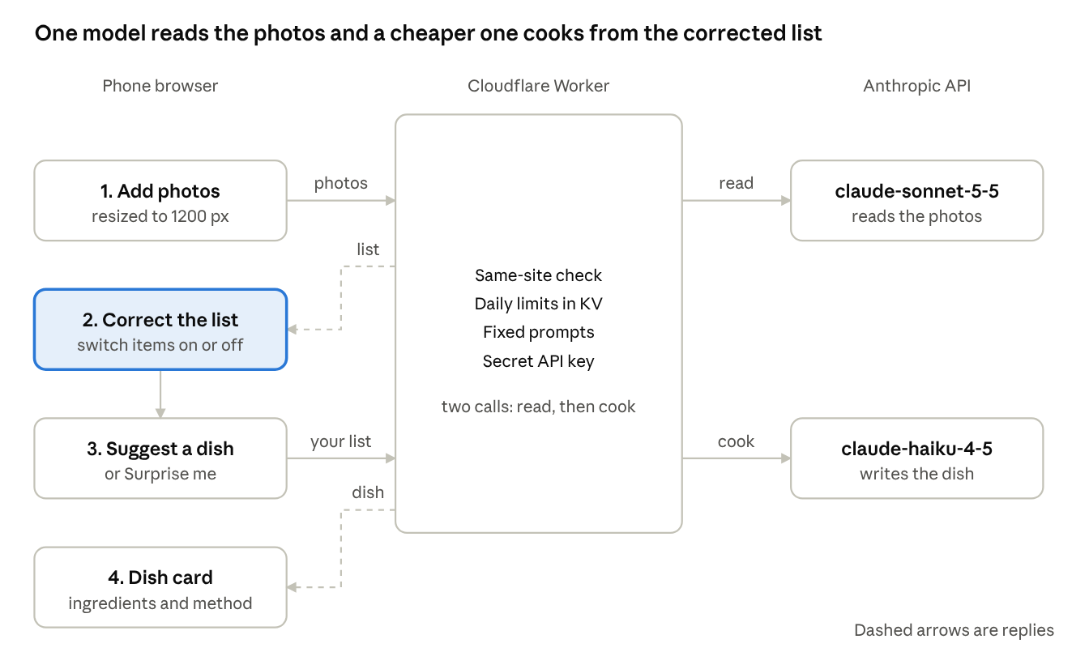
request flow · 2 calls through 1 Worker
The browser shrinks the photos, the Worker holds the key and the rules, and the cook's correction sits between the two model calls.

Build steps and the reason for each
- 3 Oct, prototype as a Claude artifact. Typed ingredients first, then photo upload. Reason: test the idea in minutes with no servers or accounts.
- 3 Oct, found the artifact's limit. Typing worked in the mobile viewer, but the photo picker did nothing across three code changes. Reason it matters: the limit sat in the viewer, so more code would not fix it (my inference, not documented).
- 3 Oct, chose the architecture. A web page plus a server proxy plus the Anthropic API. Reason: the artifact's built-in Claude access works only inside claude.ai, so a public site needs its own API call.
- 3 Oct, set up the Anthropic account. $5.00 prepaid credit, auto-reload off, a $5 monthly spend limit and an email alert. Reason: put a hard ceiling on cost before any code goes public.
- 3 to 5 Oct, set up Cloudflare. Free account, authenticator-app two-factor, recovery codes stored privately. Reason: this account holds the API key, so it is the account most worth protecting.
- 5 Oct, wrote the worker and page, then tested locally. Mock tests covered a valid photo, bad input, blocked origins, rate limits, spend-cap errors and garbled replies. Reason: find bugs before deploying.
- 5 Oct, deployed with Wrangler. Created a KV store for rate limits, stored the API key as a Worker secret, registered the workers.dev name. Reason: the key lives only on the server, never in the page or the code.
- 5 Oct, fixed an invalid-key error. Private logs showed the exact cause; a fresh key was uploaded. Reason: visitors see a generic message while the owner sees the real one.
- 5 Oct, tuned the recipe prompt. Stovetop cooking by default, no ingredient repeated across lists, creative picks must be sensible. Reason: first outputs assumed an oven and listed vanilla twice.
- 7 Oct, split the flow in two. Step one reads the photos into an editable list; step two cooks from the confirmed list. Reason: closed containers cannot be read, so cooking from a guessed list gives flat dishes.
- 7 Oct, made correcting the list fast. Unsure items start switched off, quick-add chips cover common Indian staples, and the container note is shorter. Reason: the cook should not retype what is inside every container.

Decisions and trade-offs
Six choices shaped the build; each trades a little convenience for lower cost or higher accuracy.
Decision | Chosen | Rejected | Why
Where the tool lives | Own page on Cloudflare Workers | Staying inside a Claude artifact | The artifact could not open the photo picker on mobile, and it cannot run on a public site
Hosting for the proxy | Cloudflare free plan | Vercel Hobby | Vercel's Hobby plan is limited to non-commercial use; a lab that promotes a studio likely counts as commercial (my reading)
Flow | Two steps: read, correct, cook | One step from photo to dish | A wrong ingredient list made the dishes flat; the target is a correction under a minute, not yet timed
Models | Sonnet 5.5 reads, Haiku 4.5 cooks | One model for both | Pay for the stronger model only where vision accuracy decides the result
Unsure items | Switched off until tapped | Switched on by default | A guessed ingredient should not enter a dish without the cook's say
Photo handling | Sent to the model, not stored by the site | Saving photos for later review | Less to protect and nothing to disclose beyond the API call

Safety and cost controls
Seven layers limit what a stranger, or a bug, can spend or reach.
- API key as a Worker secret. It never appears in the page, the code or the repo; .gitignore also keeps local files out of GitHub.
- Fixed prompts on the server. Visitors send photos or a list, never instructions, so the endpoint cannot act as a free chatbot.
- Same-site check. Requests from other websites are refused.
- Daily limits. 20 tries per IP per day by default (30 on test days) and 300 across everyone, held in Cloudflare KV.
- Anthropic spend limit. $5 per month with an email alert, on a prepaid balance with auto-reload off.
- Account protection. Authenticator-app two-factor on Cloudflare, and recovery codes stored privately.
- Photos not saved by the site. They are sent to Anthropic's Claude to read the ingredients, and the page says so. Anthropic's data-retention terms still need reading before wider sharing.

Problems hit and how each was fixed
Seven problems surfaced in three days; six are fixed and one is queued.
Problem | Cause | Fix | State
Photo picker did nothing in the mobile artifact viewer | The viewer, not the code (my inference) | Moved to an own page where file pickers work | Fixed
Server error 401, invalid key | The stored key was wrong | Created a new key, uploaded it as the secret, confirmed with live logs | Fixed
Reading step returned an unreadable answer | Not confirmed; likely a long list cut off. Token limit raised from 900 to 2,000, JSON-only instruction added | Redeployed; chips then appeared | Fixed
Flat dishes from a crowded fridge | Closed containers cannot be read, so the list was guesswork | Two-step flow with an editable list and quick-add chips | Fixed
Oven recipes and repeated items | The prompt assumed an oven and did not forbid duplicates | Stovetop rule and one-list rule | Fixed
Item names squashed into circles | One style rule meant for the × button also hit the labels | Scoped the rule to the × button | Fixed
A step says to cook the omelette after it is plated | The prompt does not require steps to be physically possible in order | Add a step-order rule in the next deploy | Queued

Status and next steps
The tool is live and usable; the open work is testing, cleanup and publishing.
Done
- Live tool on workers.dev with photo reading and a correctable list (5 and 7 Oct). Owner: Tron with Claude.
- Anthropic account, $5.00 credit, $5 monthly limit and alert. Owner: Tron.
- Cloudflare account with two-factor and stored recovery codes. Owner: Tron.
Pending
- Finish the 10-photo test; 2 of 10 done. Shoot one shelf at a time, lids off. Owner: Tron.
- Add the step-order rule to the recipe prompt and redeploy. Owner: Claude.
- Delete the failed API key and check the new key's expiry in the Console. Owner: Tron.
- Lower the daily limit from 30 back to 20 after testing. Owner: Tron.
- Divide the month's Console spend by full flows run to get the real cost per dish; the estimate is about $0.01 and unverified. Owner: Tron.
- Move DNS to Cloudflare and attach chef.technoelogy.com. Owner: Tron.
- Create the GitHub repo fridge-chef under technoelogy, with a README that leads with who benefits. Owner: Tron, with Claude drafting.
- Post a LinkedIn Projects entry, led by what Consumer Health, OTC, DTC and pharma stakeholders get from it. Owner: Claude drafts, Tron posts.
- Read Anthropic's data-retention terms before sharing the link widely. Owner: Tron.

Source notes and opinions
Figures below are approximate: they come from vendor documentation and guides read through search during the build, and were not re-opened for this document. Re-check before quoting publicly.
From published sources
- Haiku 4.5 at $1 input and $5 output per million tokens: Anthropic's published API pricing.
- Free plan of 100,000 Workers requests a day, and 1,000 KV writes a day: Cloudflare's Workers pricing and limits pages.
- Hobby plan limited to non-commercial use: Vercel's Hobby plan and fair-use documentation.
- Spend-limit location in the Console: Anthropic's Console documentation. Guides disagree on the menu path, and the Billing page was confirmed on screen.
Opinion or estimate, not sourced
- About ₹0.4 per request on Haiku and about $0.01 per full flow on the two-step version. Both are my estimates from assumed token counts.
- Sonnet 5.5 pricing was not verified.
- The 80% accuracy threshold for solid items is my target, not a benchmark.
- The reading that a studio-promoting site counts as commercial under Vercel's terms is mine; Vercel's support team can confirm.

